**FUNCTIONAL AND TECHNICAL COMBINED DOCUMENTATION**

**Page (60): Trade Register for Fixed Income (Front End Url:** http://localhost:8100/page60/Page60)

**Functional Picture:**

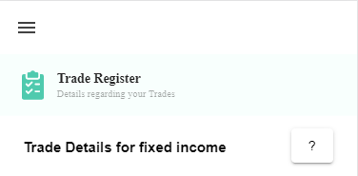

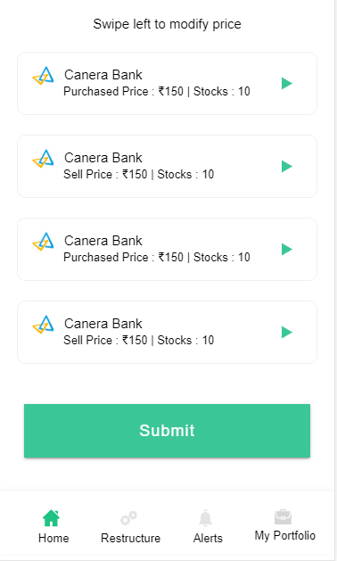

**In this Page, the user is going to see the list of Fixed Income securities that are currently in his portfolio. The user can slide each section and can edit his actual transaction price from Page 62(Add or Update Fixed Income)**

**Technical Explanation (Front End and Back End):**

**In Page60.tsx, we are calling following 1 API:**

1. TradeRegisterAPIFI: see backend python file. In this we are doing GET requests.

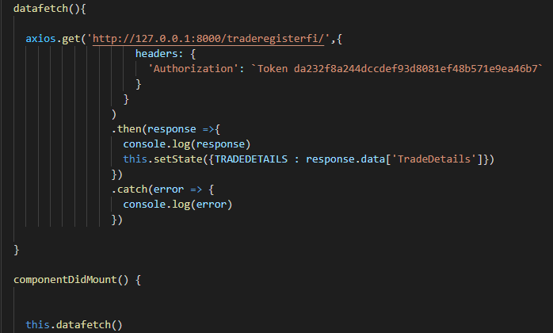

**As you can see, we are calling the** TradeRegisterAPIFI

**using this url:** [**http://127.0.0.1:8000/traderegisterfi/**](http://127.0.0.1:8000/traderegisterfi/)**. In this we are taking the Fixed Income data to populate Fixed Income Securities.**

**Kindly see the given below backend Code for this GET request.**

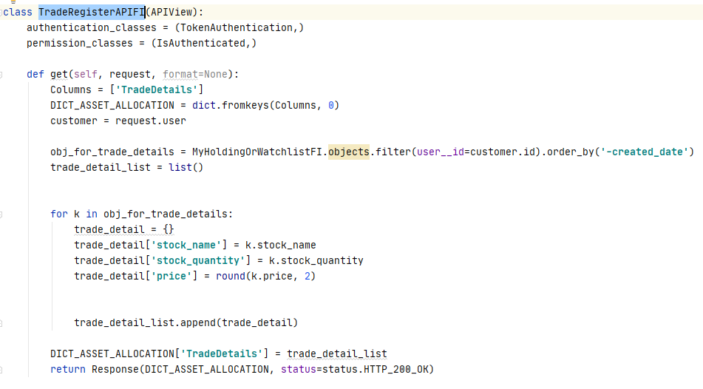

**The Above API is taking the data from the Fixed Income Database throwing the data on the front end through Response.**

**DONE!!!**